**POLITEKNIK NEGERI MALANG**

**TEKNOLOGI INFORMASI**

**TEKNIK INFORMATIKA**



**Mohammad Ariq Baihaqi**

**244107020161**

**TI – 1A**

**16**

**Class Book**

package Minggu16;

public class Book {

    public String isbn;

    public String title;

    public Book(){

    }

    public Book(String isbn, String title){

        this.isbn = isbn;

        this.title = title;

    }

    public String toString(){

        return "ISBN: " + this.isbn + " Title: " + this.title;

    }

}

**Class Customer**

package Minggu16;

public class Customer {

    public int id;

    public String name;

    public Customer() {

    }

    public Customer(int id, String name) {

        this.id = id;

        this.name = name;

    }

    public String toString(){

        return "ID: " + this.id + " Nama: " + this.name;

    }

}

**C**

**Class DemoArrayList**

package Minggu16;

import java.util.ArrayList;

public class DemoArrayList {

    public static void main(String[] args) {

    ArrayList<Customer> customers = new ArrayList<>();

    Customer customer1 = new Customer(1, "Zakia");

    Customer customer2 = new Customer(5, "Budi");

    customers.add(customer1);

    customers.add(customer2);

    customers.add(new Customer(4, "Cica"));

    customers.add(2, new Customer(100, "Rosa"));

    System.out.println(customers.indexOf(customer2));

    Customer customer =customers.get(1);

    System.out.println(customer.name);

    customer.name = "Budi Utomo";

    ArrayList<Customer> newCustomers = new ArrayList<>();

    newCustomers.add(new Customer(201, "Della"));

    newCustomers.add(new Customer(202, "Victor"));

    newCustomers.add(new Customer(203, "Sarah"));

    customers.addAll(newCustomers);

    System.out.println(customers);

    for (Customer cust : customers) {

        System.out.println(cust.toString());

    }

}

}

**Class StackDemo**

package Minggu16;

import java.util.Stack;

public class StackDemo {

    public static void main(String[] args) {

        Book book1 = new Book("1234", "Dasar Pemrograman");

        Book book2 = new Book("7145", "Hafalah Shalat Delisa");

        Book book3 = new Book("3562", "Muhammad Al-Fatih");

        Stack<Book> books = new Stack<>();

        books.push(book1);

        books.push(book2);

        books.push(book3);

        Book temp = books.peek();

        if(temp != null) {

            System.out.println(temp.toString());

        }

        Book temp2 = books.pop();

        if(temp2 != null) {

            System.out.println(temp2.toString());

        }

        for (Book book : books) {

            System.out.println(book.toString());

        }

        System.out.println(books);

    }

}

**Class TreeSetDemo**

package Minggu16;

import java.util.TreeSet;

public class TreeSetDemo {

public static void main(String[] args) {

TreeSet<String> fruits = new TreeSet<>();

fruits.add("Mangga");

fruits.add("Apel");

fruits.add("Jeruk");

fruits.add("Jambu");

for (String temp : fruits) {

System.out.println(temp);

for (String fruit : fruits) {

System.out.println(fruit);

}

System.out.println("First: " + fruits.first());

System.out.println("Last: " + fruits.last());

fruits.remove("Jeruk");

System.out.println("Setelah remove " + fruits);

fruits.pollFirst();

System.out.println("Setelah poll first " + fruits);

fruits.pollLast();

System.out.println("Setelah poll last " + fruits);

}

}

}

**Class Sorting**

package Minggu16;

import java.util.ArrayList;

import java.util.Collections;

import java.util.List;

public class Sorting {

    public static void main(String[] args) {

        ArrayList<String> daftarSiswa = new ArrayList<>();

        daftarSiswa.add("Zainab");

        daftarSiswa.add("Andi");

        daftarSiswa.add("Rara");

        Collections.sort(daftarSiswa);

        System.out.println(daftarSiswa);

    }

}

**OUTPUT**

DemoArrayList

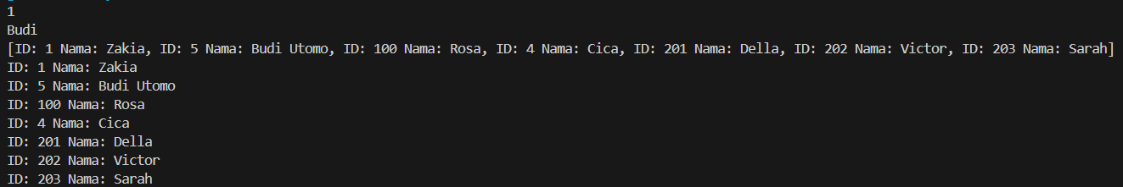

StackDemo

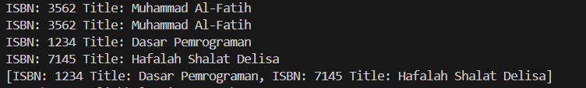

TreeSetDemo

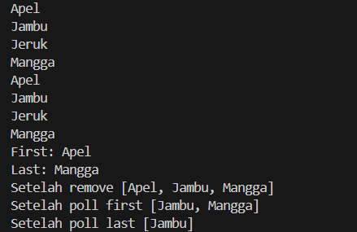

Sorting



Link Github : <https://github.com/Ariqq16/semester2>